Software Documentation
Contents
Introduction 2
Software Documentation Importance 3
System Components 3
Admin or Member Login 3
Admin Actions 3
Member Actions 3
Database Structure 4
Library Management System User Guide 4
Introduction 4
What Can an Administrator Do? 4
What Can a Member Do? 4
Extra Information 4
System Requirements & Installation Guidelines 4
Installation Steps 5
Getting Started – Admin Login 5
Admin Guide (Admin Tab) 6
Managing Books 6
Adding Books 7
Updating Books 7
Removing Books 7
Viewing Books 8
Managing Members 8
Adding Members 8
Updating Members 8
Removing Member 9
Viewing Members 9
Viewing Loans 9
Member Guide 10
Member Login 10
Viewing Books 10
Borrowing Books 10
Returning Books 10
Checking Loans 11
Troubleshooting 11
Debugging and Error Handling 11
Code Explanations and System Logic 14
Creating Tables 14
Database Connection 14
Admin Authentication 15
Managing Books (Adding, Removing, Updating) 15
Updating Books 16
Borrowing Books 16
Returning Books 17
Fine Calculation 18
Explanation of Programming Concepts 18
Variables 18
Integers (int) 18
Strings(str) 18
Float(float) 18
Example 19
Conditional Statements (if-else) 19
Functions 20
Exception Handling (try-except blocks) 20
SQL Operations 20
Loops 21

Introduction
My Library Management System allows the admin process of managing books, members and loans to be streamlined, making the execution of tasks more efficient.
The system is created using the python programming language handling the back-end logic and the graphical user interface using an extension called PysimpleGUI, allowing a clear visualisation on different roles with admins and members navigating their own tab separately. The system uses the SQLite3 database to store data and writes to a .JSON file for back up purposes, preserving any data.
A digital system is more reliable than a physical one, it prevents data loss and reduces human error when keeping records, furthermore, manual input can be tedious and time consuming leading to inefficiency and incorrect inputs, whereas Pythons built in validation allows inputs like book details, member information and loan dates to have the correct information added and mitigates any possible errors using try except handling and logging.

Software Documentation Importance
Software documentation is important in making sure a system is understood and able to be maintained to its full ability. This documentation explains in detail the systems feature, logic and structure used ensuring that future developers can modify and improve the software efficiently. When documentation is done to a good level, troubleshooting and debugging is an easier as it would already identify previous issues and how they were taken care of. With this documentation provided, new users and developers will have the adaptation period shortened as the information needed for the program is all provided.

System Components
The system automatically backs up data to a .JSON file on close.

Admin or Member Login
Authentication is validated using a query in SQL where ‘?’ is used as a placeholder and replaced with a value when given.

Admin Actions
Updates are stored in the database using books/members/loans tables.

Member Actions
The system checks availability of a book in books table, looking at the quantity and validity.
If available, the database will create a new loan record and insert that into loans table and the book quantity will be deducted by 1.
When a book has been returned to the database, the return date and fees if any are calculated and input into the database.

Database Structure
SQLITE Database
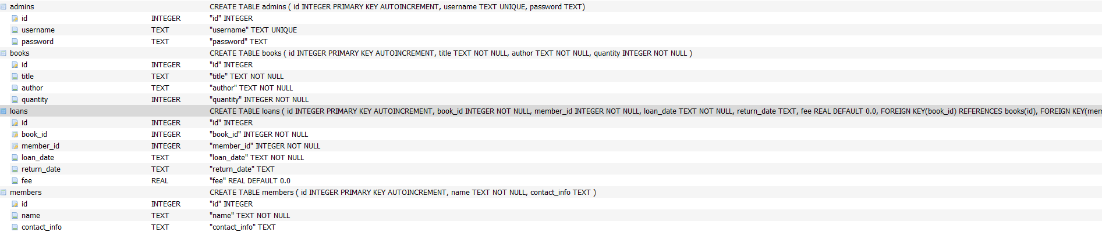
The loans table links books and members together using foreign keys ensuring accurate tracking of borrowed and returned books and provides accurate loan management.

Library Management System User Guide

Introduction
This Library System has been developed to help library admins and members in managing their books.

What Can an Administrator Do?
- Add, Update, Remove and view all books and members in the database
- Track all loans and fees

What Can a Member Do?
- Members can login with their given member_id number
- Borrow, return and books
- View their loan history and previous fines given.

Extra Information
This system was built using python, while using PysimpleGUI for the graphical interface and SQLite3 for storage of data.

System Requirements & Installation Guidelines
- Python 3.12 or newer installed on your system.
- The required libraries used to run this system must be downloaded, type as seen below:
pip install PySimpleGUI sqlite3 json datetime logging

Installation Steps
- Download system files
- Run the pip install command above.
- Run the system by typing python library_management_system.py

Getting Started – Admin Login
- On Launch you will be greeted with a login interface where you can login with a username and password (Username – Admin, Password Admin123)
- You will also be given the choice to click register, where you will be able to create a new admin account
- This login page is a barrier of security to protect the system from anyone being able to access
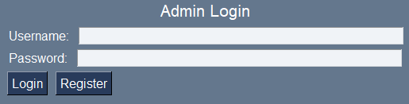

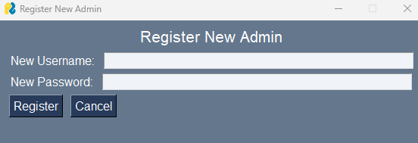

Admin Guide (Admin Tab)
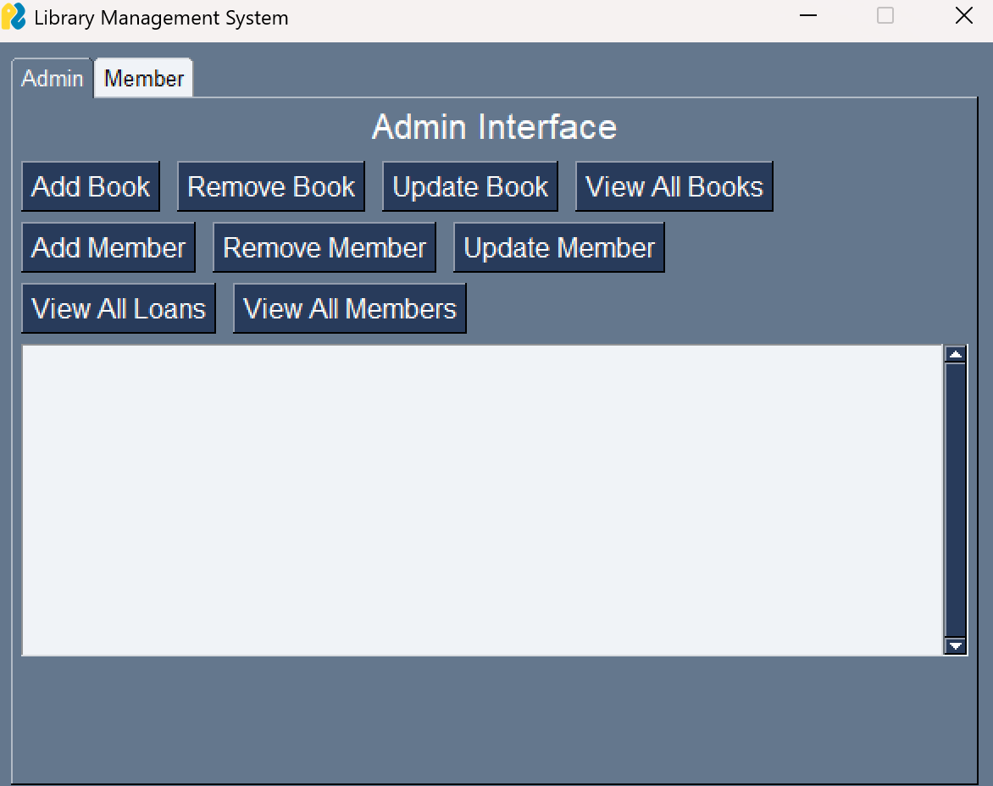

Managing Books

Adding Books
Where you can add a new book to the database by giving the name of the book, the author and how many books are available in the library.
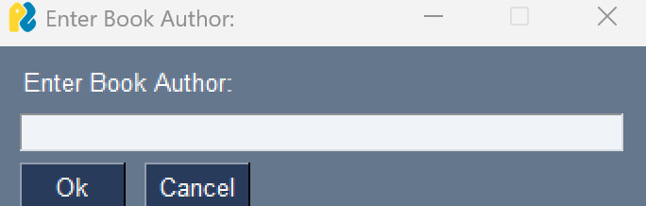
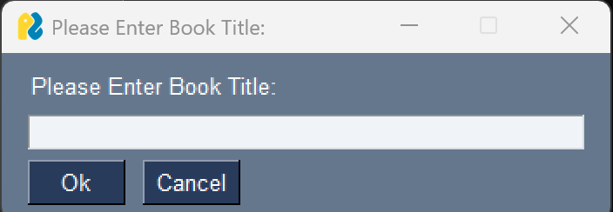
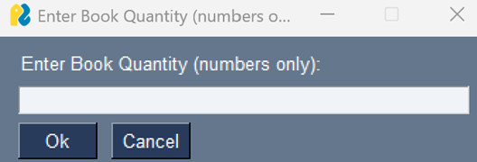

Updating Books
Here you can modify a book already in the library by providing the book_id.
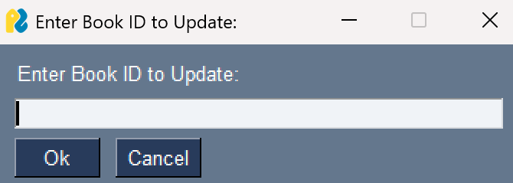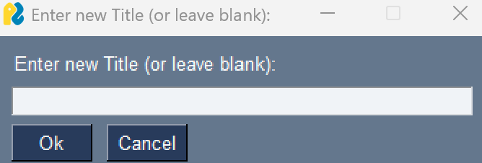
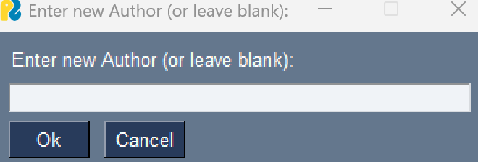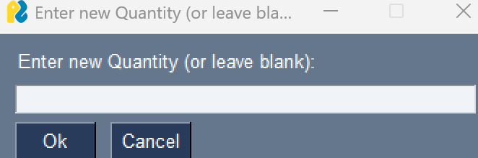

Removing Books
Here you will be able to delete a book by providing the book_id.
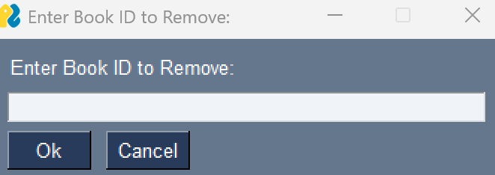

Viewing Books
See a list inside the system that queries the database to return all books in the library. 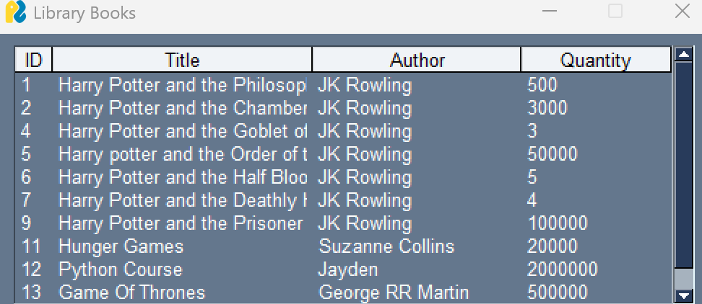

Managing Members

Adding Members
Enter the members name and contact information (email), once this information is input correctly, you will then be shown the members id number which they will use to login into their account.
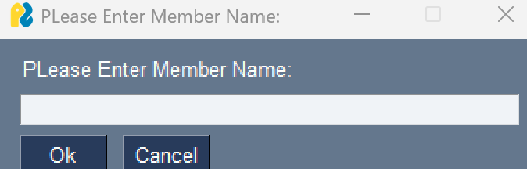
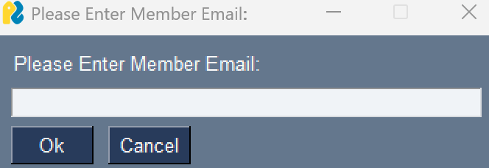

Updating Members
Allows you to modify the given member_ids name and contact information.
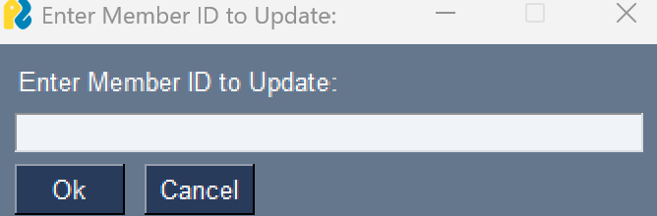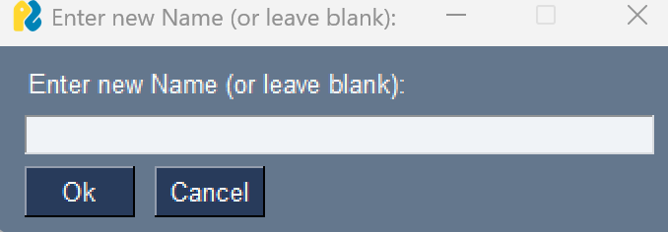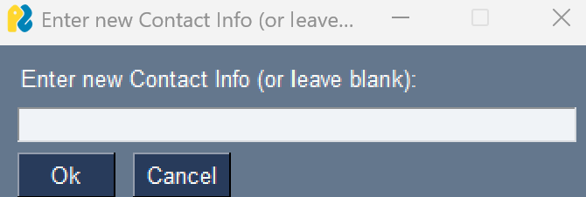

Removing Member
This allows you to delete a member from the system by providing their member_id. 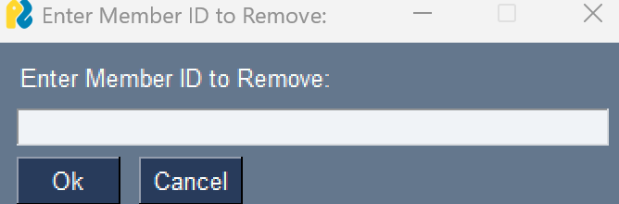

Viewing Members
See a list inside the system that queries the database to return all members in the library.
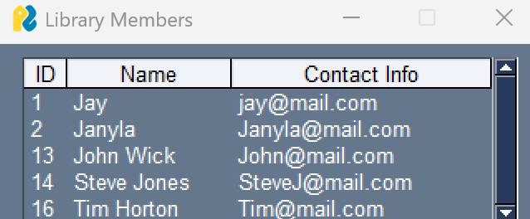

Viewing Loans
Clicking view all loans will allow the admin to see all previous and current loans and their given fees showing the book at return date also.
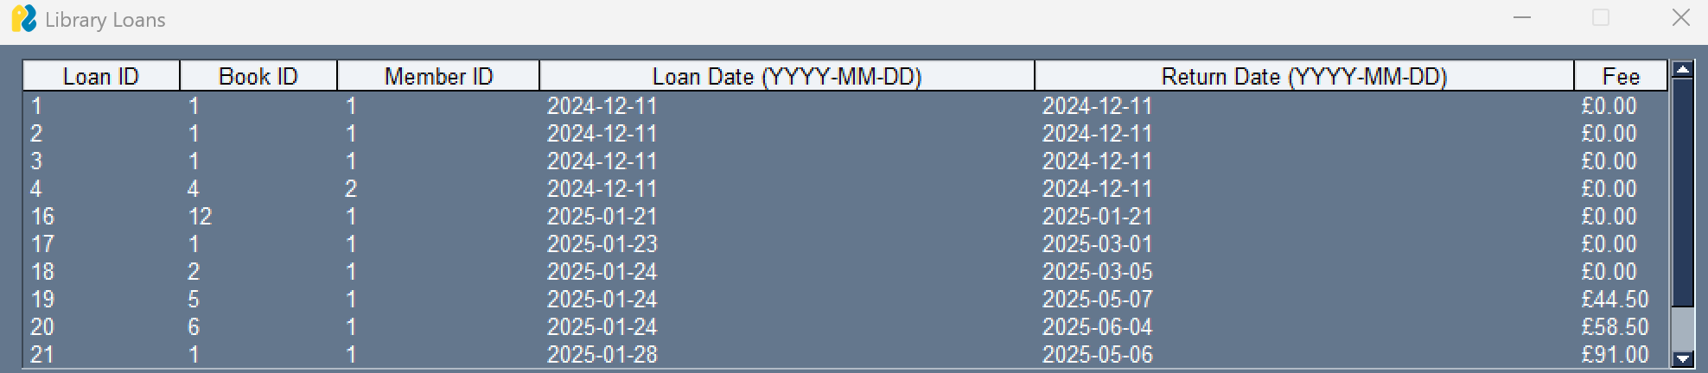

Member Guide

Member Login
First enter your Member-ID, then click login to access your account. 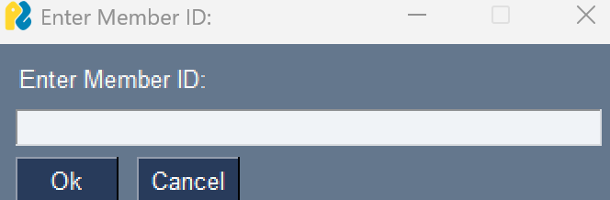

Viewing Books
Click view all available books to see every book in the database.


Borrowing Books
Clicking borrow a book will prompt you to give a book_id, if the book is available you will be able to borrow the book.
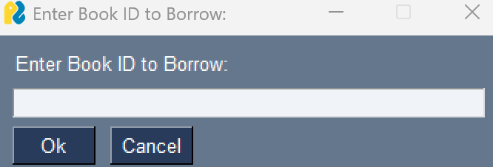

Returning Books
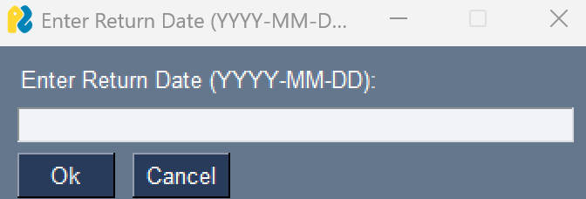
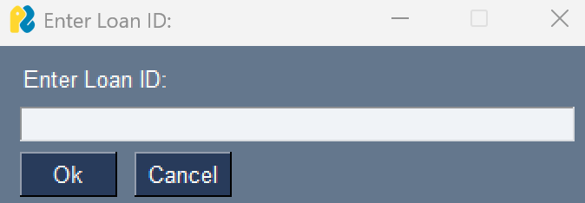
Clicking return a book will prompt you to input the loan id given when you took out the book, and to give the date that you are returning the book, if the book is outside the set 7 day period, you will be charged £1 for every day over 7 days that you do not bring back the book.

Checking Loans
Clicking view my loans will show you every book you have withdrawn, when you withdrew and if you have returned it to the library, if you haven’t it will say not returned until you have including previous fees.
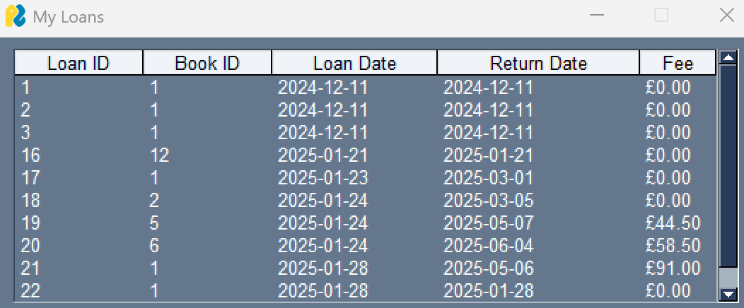

Troubleshooting
Issue | Possible Cause | Solution
Cannot log in as admin | Wrong Input | Verify username/password
Book not available | No copies left | Wait until a book is returned
Incorrect loan_id | Wrong input | Verify loan_id before returning book

Debugging and Error Handling
Debugging is an integral part of being able to identify and resolve errors in the library management system. To make the system run smoothly with no unexpected crashes , I used a structured debugging approach to navigate this including:
- Reading the traceback analysis (error messages) to see the specific line of code that is affecting the program.
- Using print statements and logging to confirm what the output of the action will be and track its behavioural effects.
- Trying different inputs to see unexpected errors and perform error management
- Using try-except blocks to handle exceptions without crashing the program, for example when removing a member, if you wrote the number ten as a word the system would crash due to a literal being given but once adding a try and except ValueError I was able to stop the system from crashing.
By testing and tracking errors, I was able to ensure that both my admin and member functionalities run smoothly.

Error | Cause | Solution
Variable Assignment Error | Used book = sg.popup_get_text instead of book_id | Changed variable name to book_id
Data Not Saving After Restart | Missing commit() statements in database updates after calling a function | Added cursor.connection.commit() after updates
Late Fee Not Displaying When Querying Loans | Fee column missing from loans table | Added a new column and updated SQL queries
Member Login Not Working | Incorrect SQL query missing WHERE | Fixed query: SELECT * FROM members WHERE id = ?
Admin Panel Accessible Without Login | No authentication check | Implemented a logged_in_admin state
Buttons Not Performing Actions | Even handlers not linked to button | Updated event loop with correct button handlers
Unexpected Crashes | No error handling for invalid inputs | Used try-except blocks to catch errors

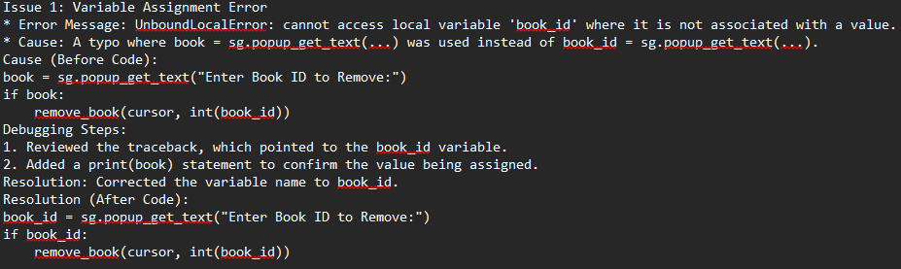
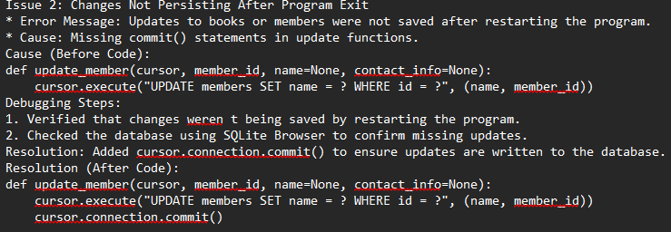
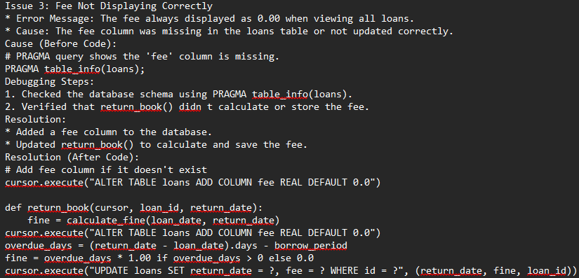
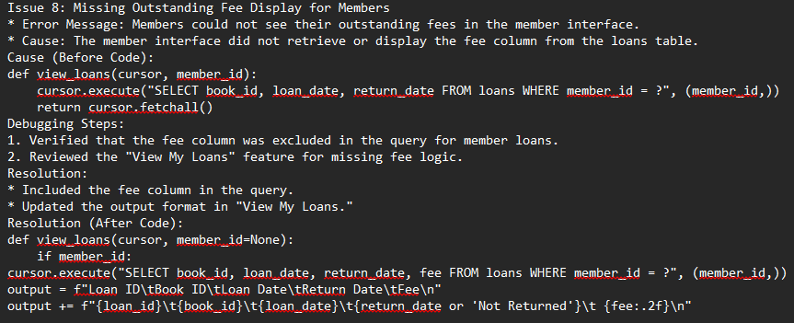
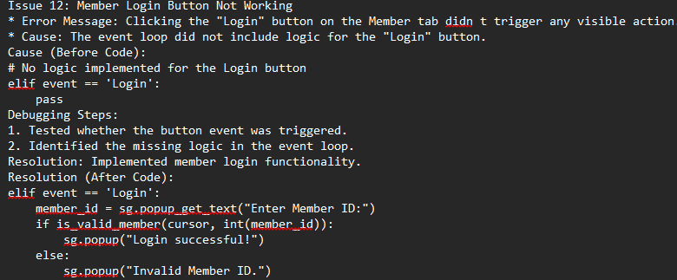

Code Explanations and System Logic

Creating Tables
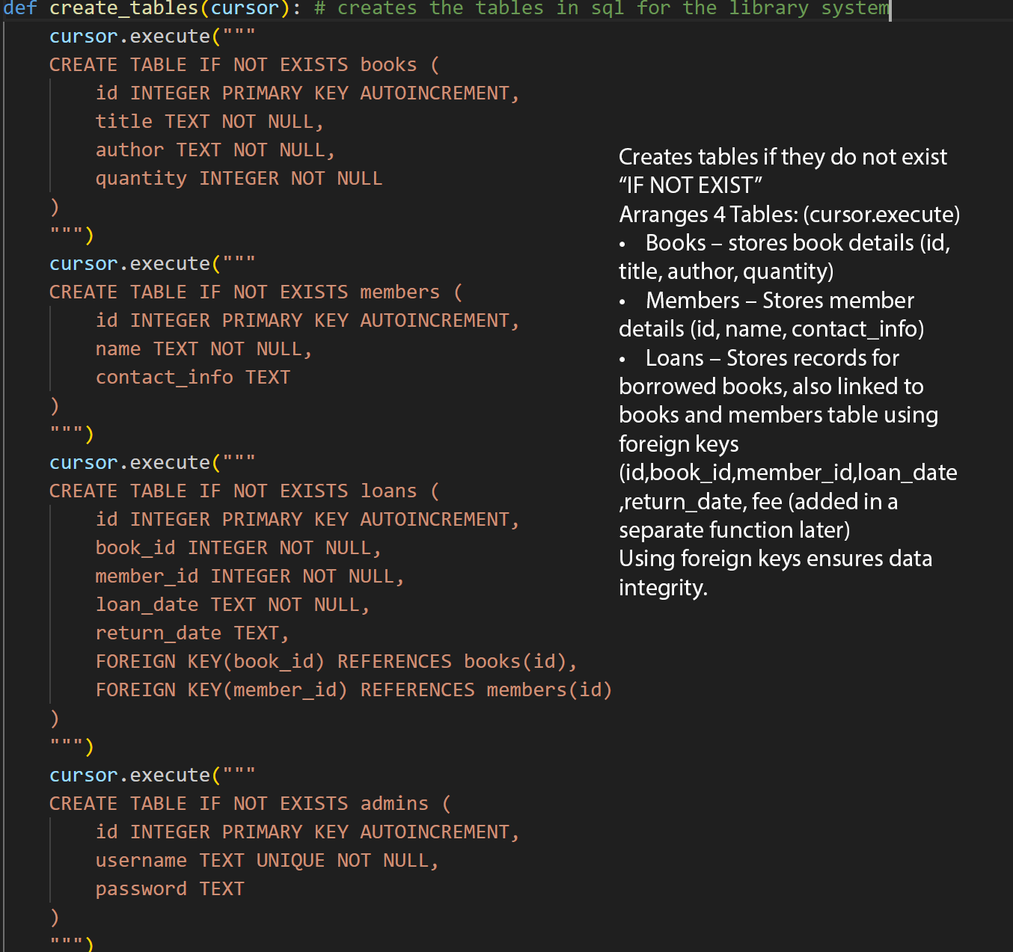

Database Connection
- Connects the code to library.db allowing us to interact with the database (sqlite3.connect())
- Enables foreign key constraints to enforce relational integrity to make sure data being used from foreign keys is correct
- Returns a cursor allowing us to manipulate the database

Admin Authentication
Queries the ADMINS table to see if the given username and password exist within the database. ‘?’ is used as a placeholder parameter to prevent SQL injection, if login is successful, it will return TRUE and if not FALSE

Managing Books (Adding, Removing, Updating)
- Inserts a new book into the BOOKS table using the parameters given to replace the ‘?’ parameter
- Saves the changes by executing cursor.connection.commit()
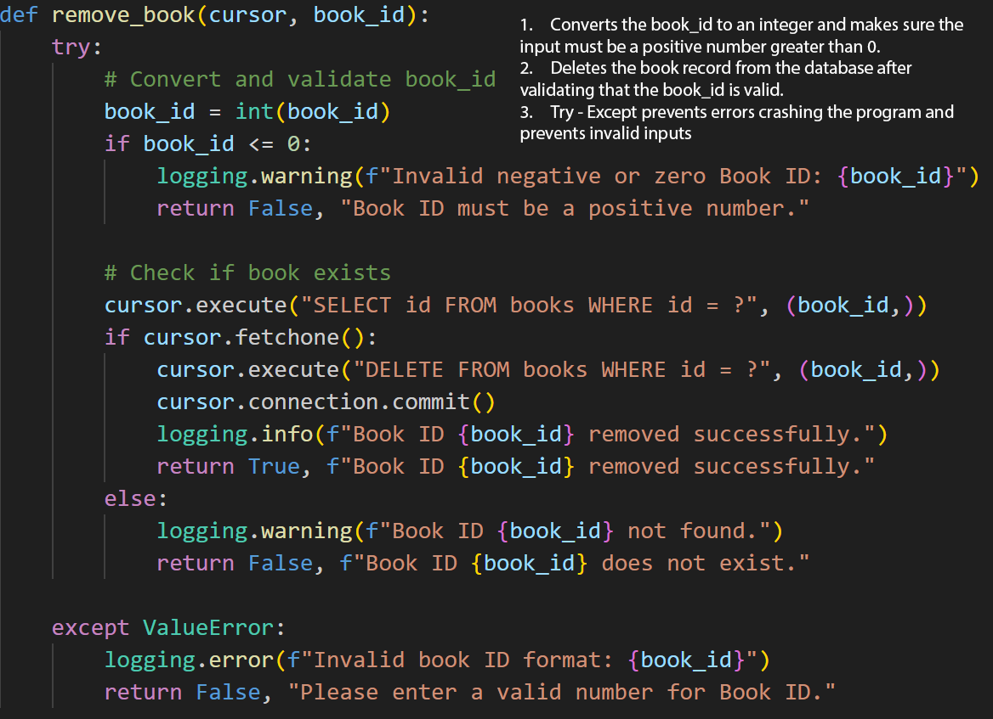

Updating Books
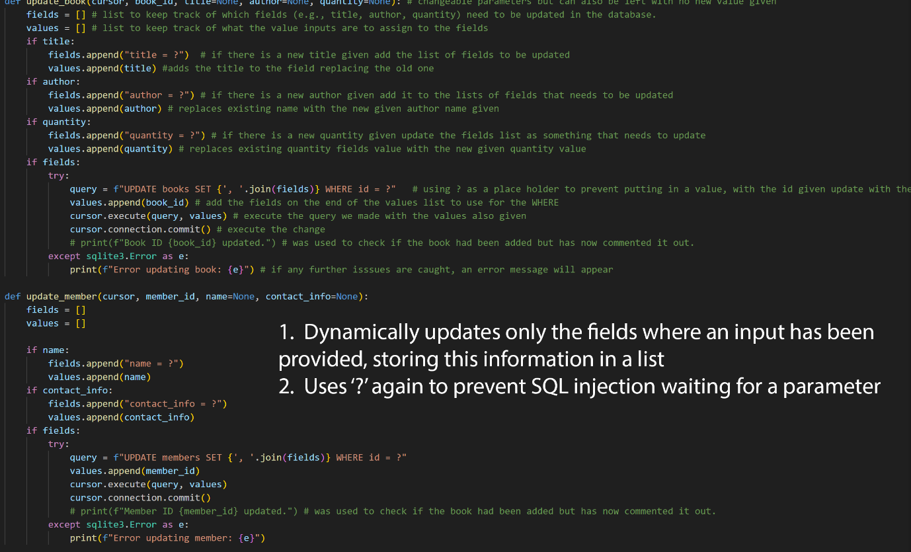

Borrowing Books
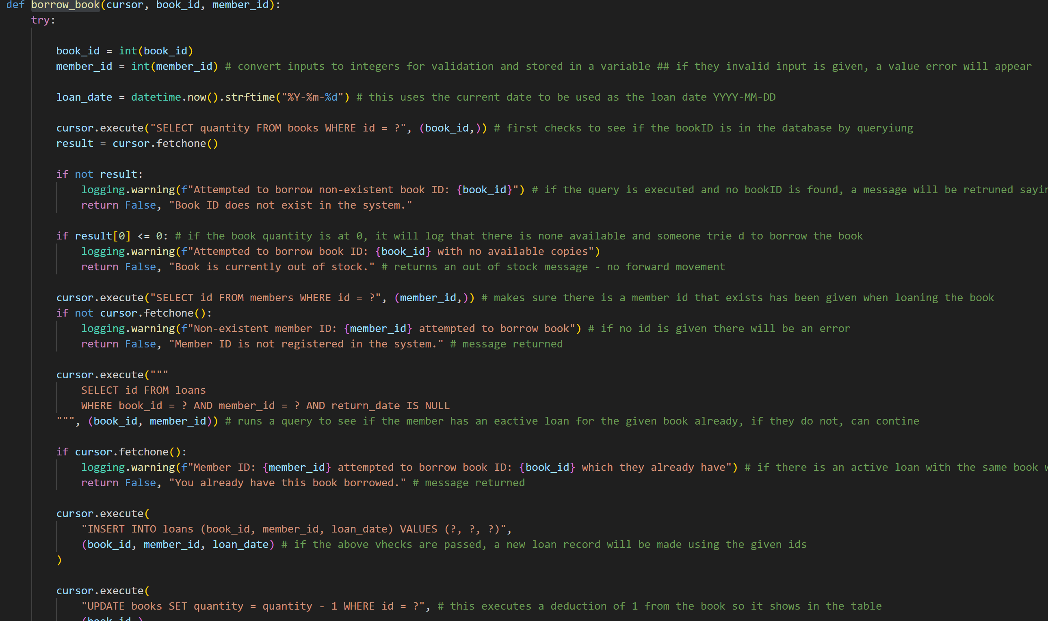
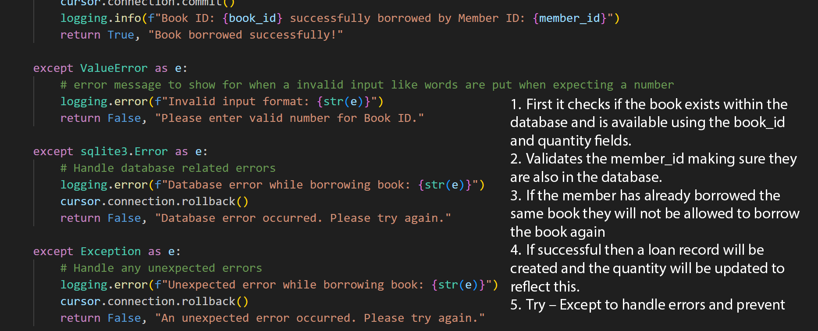

Returning Books
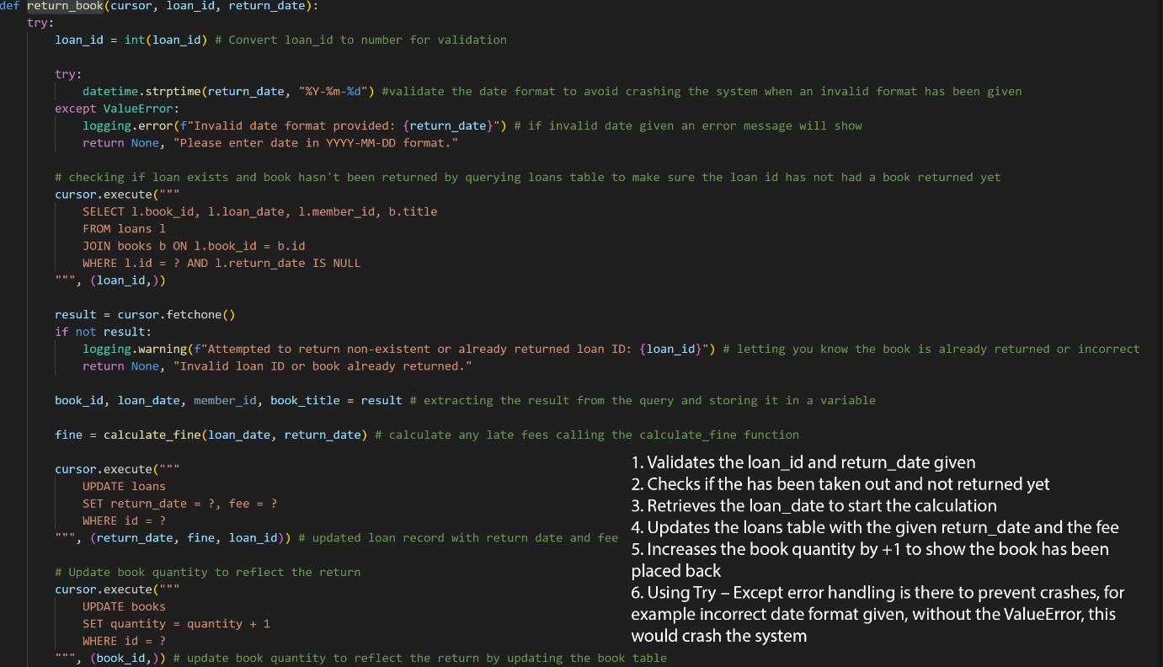
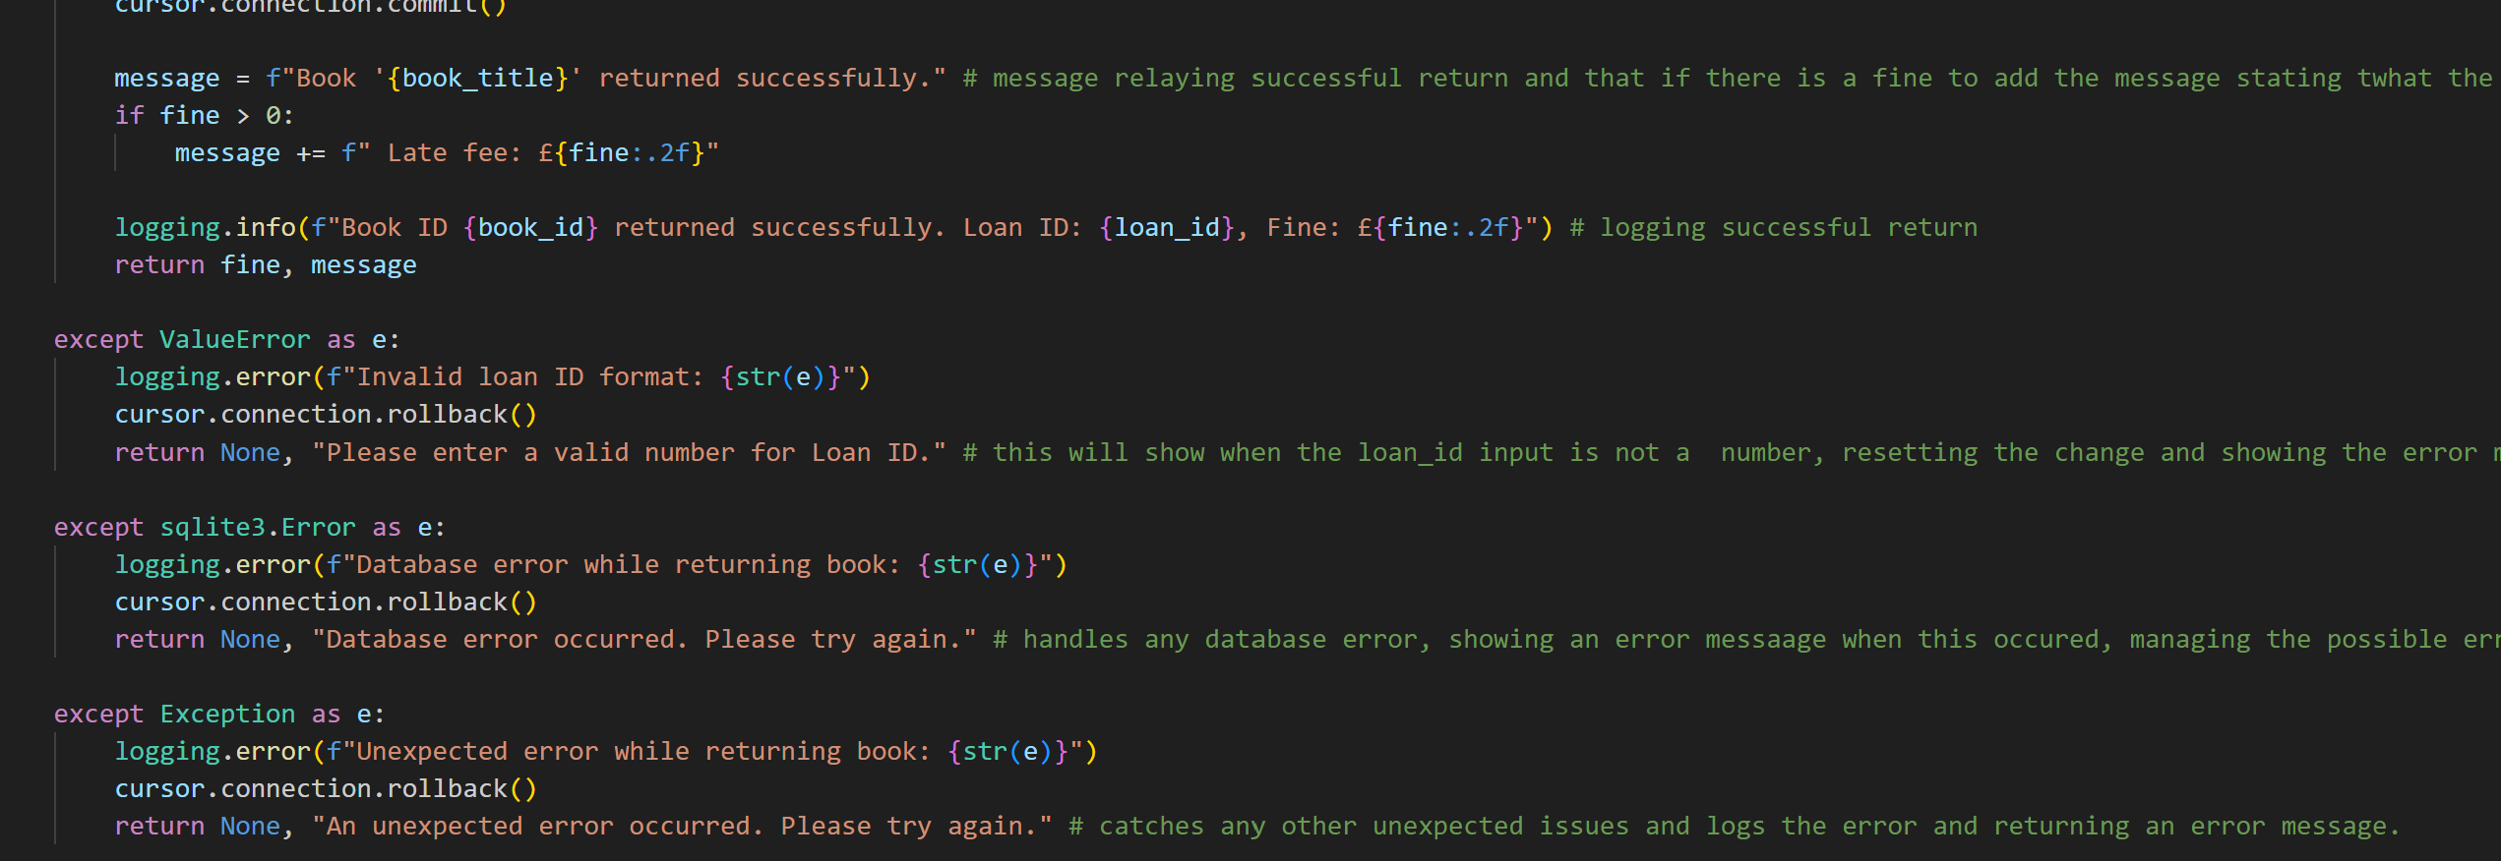

Fine Calculation
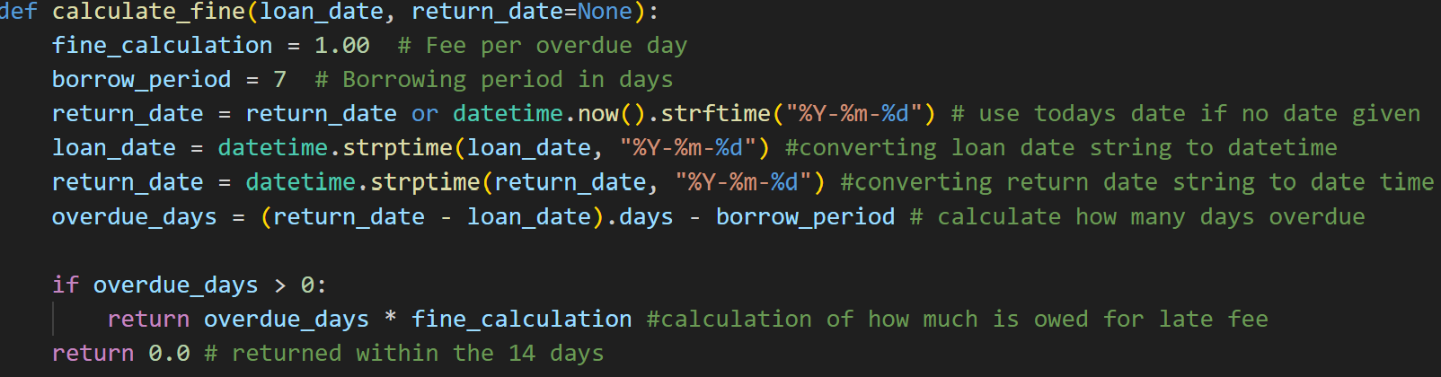
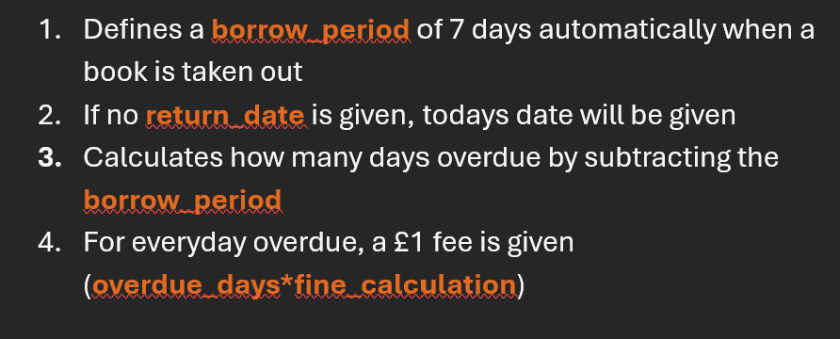

Explanation of Programming Concepts

Variables
Variables are used to store data either globally or locally that can also change. Different data types are used to store different types of information

Integers (int)
Integers are used for IDs and quantities as they allow mathematical operations like adding and taking away.

Strings(str)
Strings are used to store text-based information like titles of books author names and dates making sure they are easily readable and searchable in the database.

Float(float)
Floats are used for calculations like we have used for the late fees as they are decimals and allow for greater precision, prevents rounding for accurate transactions.

Example
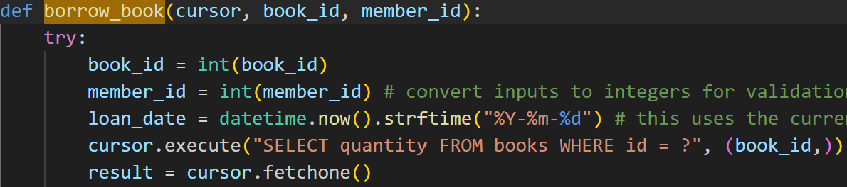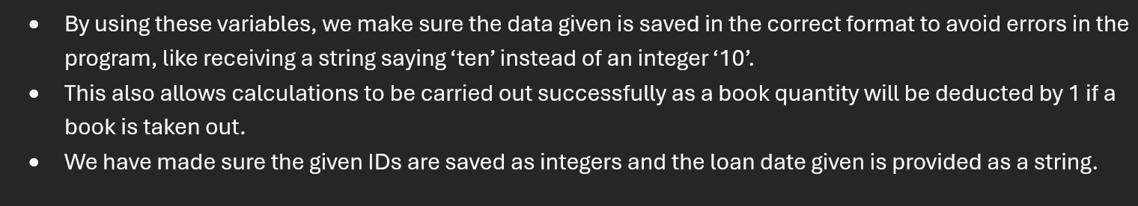

Conditional Statements (if-else)
Conditional statements allow the system to execute specific actions based on Boolean logic, ensuring logical decision making for borrowing, returning and managing books. Here when a user tries to borrow a book, the system will first check if the book is available before carrying out the loan.
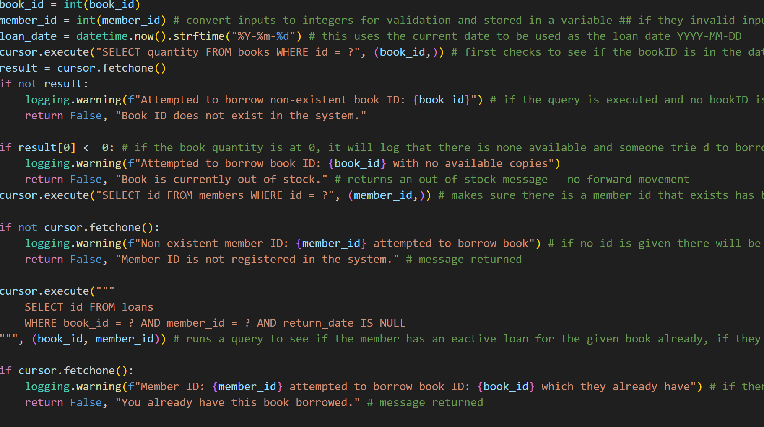
Here we have used multiple if statements as conditional check to make sure that a book can be taken, we used the if not statement to handle whether there is a correct bookID given, if there is an available quantity for said book, if the memberID given matches in the database and also if they already have that book loaned out, only after these conditions have been passed, the book will be allowed to be taken out.

Functions
Functions allow efficiency by allowing code to be reused without repetition.
This function takes three parameters (title , author and quantity – int), and inserts them in to the SQL query where there are ? as placeholders (preventing SQL injection) to add this book in to the database, putting the values instead of the ?, using cursor.commit.execute to save these changes.

Exception Handling (try-except blocks)
This is how we prevent the program from crashing when an unexpected error occurs.
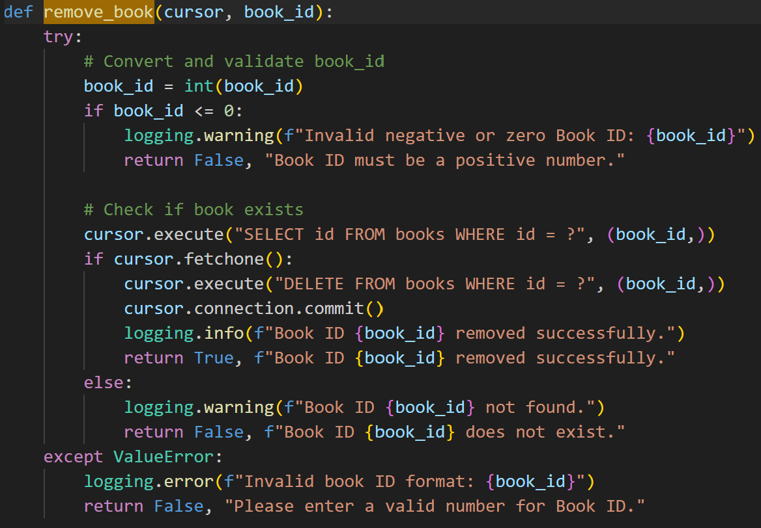
With the use of try-except blocks, if an invalid number format had been given, the system will return a message stating that a valid number has been given and to try and do it again where a valid ID is given, if this was not there when for example a string is given, the system would crash abruptly with no error explanation.

SQL Operations
SQL queries allow the database to store, insert, update, retrieve and delete data from it.
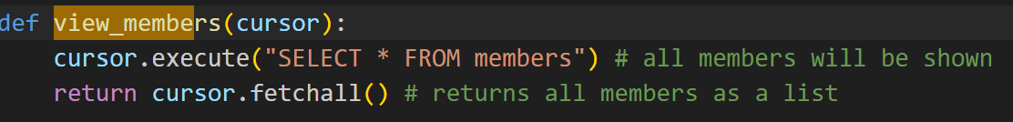
This uses .fetchall() to retrieve all the data at once instead of one by one and keeps the information organised and accessible.

Loops
Loops in programming are when a process is repeated multiple times until a condition is met, for the ‘View My Loans’ event, the loop helps display the loan records for a logged in member only and manages the interaction in the window.
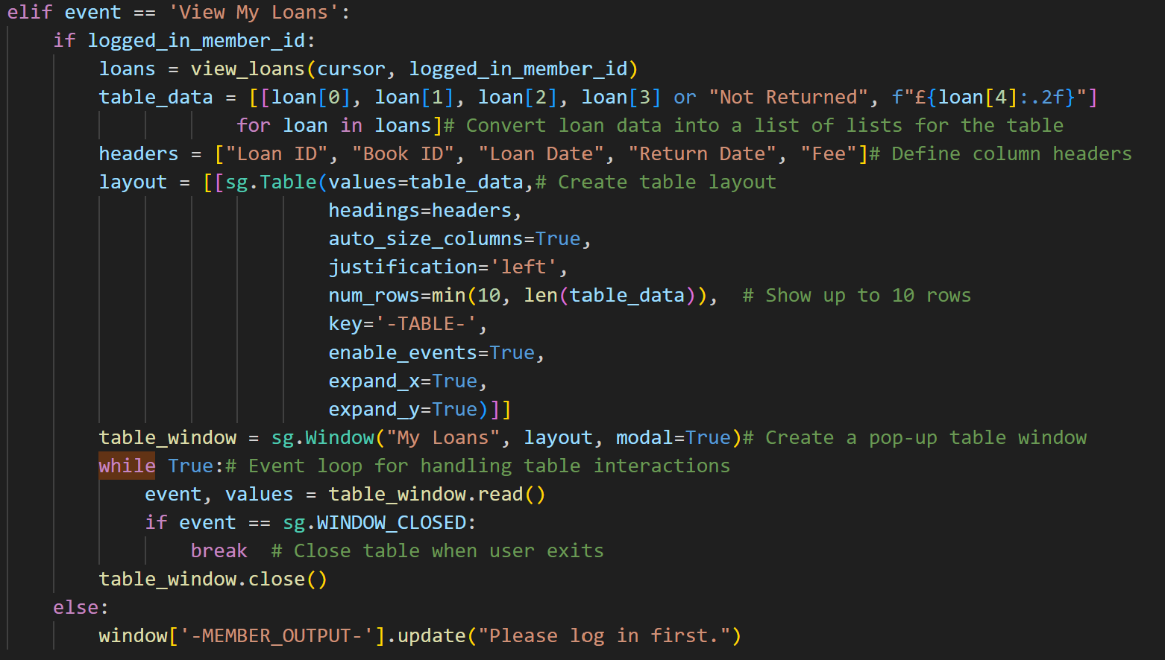
First each loan in loans represents a row in the database, the loop takes the specific loan details given and formats them as we have given them, also stating that is no return date is given then will be replaced with not returned, this loop automatically stops when all records are processed allowing it to be less error prone and a while loop is not needed here as there is no condition to be checked after each iteration. The while loop keeps the table open for user interaction and closes when the user exits out with the break statement. This helps with efficient data handling and the preventing of crashes as the variable is storing which member id is logged in.

